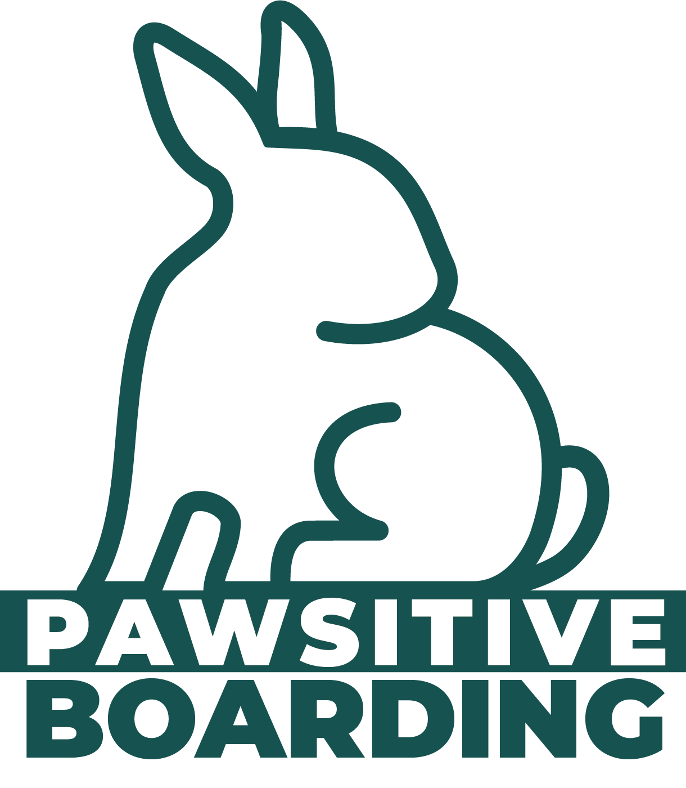
Boarding Contract

Name: ___________________________________________________________
Address: _______________________________________ City: __________________________ Zip: _____________
Phone: __________________________________ Cell: _____________________________________
Boarding Dates: _____________________________________________________
Emergency Contact: __________________________________ Phone: __________________________________
Pet Name: _________________________________________
Pet Age: ______________________________
Sex: MALE FEMALE Spayed/Neutered?: YES NO

Pet Name: _________________________________________
Pet Age: ______________________________
Sex: MALE FEMALE Spayed/Neutered?: YES NO

Pet Name: _________________________________________
Pet Age: ______________________________
Sex: MALE FEMALE Spayed/Neutered?: YES NO

Current Veterinarian: _______________________________________________
Address: _________________________________ City: __________________________ Zip: ________________ Phone: _____________________________________

1. Does your pet(s) have any special needs or medical conditions? YES NO If yes, please describe: __________________________________________________________________________________________________________________________________________________________________________________________________________

2. Is your pet(s) taking any medicine? YES NO
If yes, please list medications, dosage & schedule:
_____________________________________________________________________________________________________
3. What is your pet(s) feeding content and schedule? For example, 1/8 cup Oxbow Adult Pellets PM, veggies AM, free feed orchard hay etc. Please indicate below:
_____________________________________________________________________________________________________
4. Are there any fruits/vegetables that your pet(s) CANNOT eat? YES NO If yes, please list below:
____________________________________________________________________________________________________
5. Is there anything else we could do to make your pet’s stay with us more comfortable?
____________________________________________________________________________________________________

Medical Care
I authorize medical care for my pet(s) if Pawsitive Boarding feels it is necessary and cannot contact me in a safe time frame.
Please circle: NO YES

Is there a monetary limit on medical care your pet(s) may need?
NO YES Amount: $___________________________
I have advised Pawsitive Boarding of all medical histories/current medical issues, regarding the health of any pet(s) being boarded. I have read this contract and agree to all items mentioned herein. I understand any environmental changes can cause stress-related illness or exacerbate pre-existing conditions in the pet(s) and will not hold Pawsitive Boarding or any of its members responsible for illnesses, injuries or deaths that may occur while in their care.
Any unclaimed pets come under legal ownership/guardianship of Pawsitive Boarding after 30 days of expired or unpaid contract.
Signature: _________________________________________ Date: ____________________

